YORKSHIRE COMMON APPLICATION FORM (YCAF) INITIATIVE
2022

Introduction
Yorkshire Funders has brought together a group of local charitable trusts and foundations who want to try and make the application process for grant seekers easier and faster in order to help local charities and voluntary organisations during these challenging times when demand for their services is higher than ever.
The Yorkshire Common Application Form (YCAF) Task Force has held a series of meetings which began in July 2021 and have included consultations with Yorkshire funding advisors and local frontline groups. Having debated numerous options with regards to the content, format of the form, and how grant seekers access the application form, the Task Force agreed that it’s best to keep things simple to begin with and then based on further feedback from local funders, funding advisors and grant seekers, the form and the initiative can be developed over time. But it’s important to start somewhere.
We hope that your funding organisation will join the initiative and adopt the Yorkshire Common Application Form. To date, the following funders have committed to adopting the form:
Charles & Elsie Sykes Trust Sirius Minerals Foundation
East Riding of Yorkshire Council South Yorkshire Community Foundation
Joseph Rowntree Housing Trust Tarn Moor Estate
Leeds Community Foundation Wakefield & District Health & Community Support
Sir George Martin Trust

The Yorkshire Common Application Form (YCAF)
The YCAF, which can be reviewed here, takes the key elements of the Task Force funders’ current applications forms for grants in the region of £5,000 and under. The Task Force carried out an analysis of 10 forms and included the most common questions and information required in the YCAF, working to ensure that the form wasn’t too lengthy and time consuming to complete, whilst still meeting the needs and individual criteria of most local funders.

The idea of having a portal where the YCAF could be accessed by grant seekers and returned was discussed, but feedback from funding advisors and voluntary organisations said how important it was for them to keep the relationship and contact with each funder, and this would cost a significant amount. As a result, the initial aim of the YCAF is to save grant seekers time by numerous local funders asking them exactly the same questions in the same format, but they may wish to slightly alter their answers in order to ensure they are meeting each individual funder’s criteria and areas of focus.

Extensive research was carried out by the Task Force to decide which online application form tool to use and it was felt that Jotform was the right platform due to its simplicity, efficient customer support, ability to be integrated with systems like Salesforce and the no cost option for 100 application forms to be returned to each funder every month.

- The Task Force recommends that the YCAF is used for grants in the £5,000 region and under, or as a first stage application form for larger grants.
- In order to ensure that the application form remains ‘common’, it is vital that funders do not edit the form. However, some funders may need to take the form wording and format and replicate it for use on their specific system.
- Each funder that joins the initiative will be able to include their own logo on their YCAF. Yorkshire Funders will be hosting a paid for Jotform account which enables us to provide a ‘clone’ of the form to each funder. This in turn means that each funder can then choose how they wish to make the YCAF available to their applicants.
  - This could be via a link embedded on their website which they complete online – the funder will receive a confirmation email for each application returned and the completed form will be available in their Jotform account portal in the Tables area.
  - This link can also be emailed to applicants and an editable PDF version of the form can be created to email to applicants.
- The Task Force have prepared a YCAF Guidelines template document which can be edited by each individual funder and provided to all applicants along with the YCAF. This should ensure that each applicant is clear about how to complete the form and each funder’s guidelines.
- The Task Force have taken expert advice relating to GDPR. Two simple steps need to be taken which are listed below.

Steps to take when joining the YCAF Initiative
- Decide how you want to make the YCAF available to applicants/what format or application will you use, and how your organisation will collate the applications for review.

- Email yorkshirefunders@gmail.com or call Carla Marshall, Yorkshire Funders’ Co-ordinator on 01423 810222 to confirm your organisation is interested in joining the initiative and ask any questions you may have.

- Set up a Jotform account in your organisation’s name – most funders should find the free package will suffice, but it is advised to look at all the options https://www.jotform.com/pricing/. Like any online platform such as Mailchimp or Eventbrite, it takes a bit of time to get to know Jotform so we would advise that one staff member or trustee who is skilled/interested in getting to know new online platforms is chosen to set up the account and form. Use the Jotform Instructions below to set up your form.

- Yorkshire Funders will provide the YCAF Jotform URL so that a ‘clone’ of the form can be created in your Jotform account, as well as the YCAF Guidelines template document for you to edit and made specific to your organisation.

- Complete the Jotform Data Processing Addendum which can be found here https://www.jotform.com/gdpr-compliance/dpa/ and submit to Jotform.

- Include the following notes within your organisation’s Privacy Notice:
- Under the heading ‘What data do we need?’ or similar include the following note: Accessibility requirements regarding documentation or support with communications.

- Under the heading ‘Why do we need this data?’ or similar include the following note: [Name of funder] has a legal duty to comply with the Equality Act (2010). This means that when we process your data to meet your accessibility requirements our lawful basis is legal obligation under article 6(1)(c) of UK GDPR. Our processing of special category data, such as any health information you give us will be based on consent, article 9(2)(a).

- Under the heading ‘Do we use any data processors?’ or similar include the following note:
Your data will be held externally on cloud-based services or on the systems of partners who process information on our behalf.

We use Jotform to collect information on our behalf. Any data collected by Jotform is stored on UK servers. You can read their Privacy Policy here https://www.jotform.com/privacy/

We are committed to storing data securely wherever it is held, and ensuring it is only accessible to authorised personnel. Where data is stored on partner systems we expect them to adopt security practices aligned with our own.

- Add the following wording on your website next to the YCAF and/or in emails when you send applicants the form: (Name of funder) is a participant of the Yorkshire Common Application Form initiative (YCAF) which aims to make the application process for grant seekers easier and faster. The other YCAF participants can be reviewed at https://www.yorkshirefunders.org.uk/resources/

- When you are ready to start using the YCAF, inform Yorkshire Funders and provide your organisation’s logo (if you have one) and your organisation’s name and website (or contact information if no website) will be added to the www.yorkshirefunders.org.uk/resources page initially, alongside the other funders who have adopted the YCAF. Over the summer a new, dedicated YCAF page on www.yorkshirefunders.org.uk will be added. Funding advisors and grant seekers will then be able to see all the funders who are using the YCAF, which will be another useful source of grant information for those looking for funding.

- Once you and your applicants have started using the form, please provide feedback to Yorkshire Funders and make them aware of any issues as the YCAF Task Force will continue to meet and assess the initiative’s progress.

Jotform Instructions
- Set up your Jotform account and Login. Make sure the email address you have used is for the person who will be checking for incoming applications and using Jotform.
- Read the FAQs first to get a feel for Jotform https://www.jotform.com/faq/
- Follow the steps here to create your organisation’s Yorkshire Common Application Form https://www.jotform.com/help/42-how-to-clone-an-existing-form-from-a-url/. You need to paste in the URL which Carla sent you.
- Your form will then be listed in My Forms.
- You will then need to replace the Yorkshire Funders logo with your logo and can also type in your organisation’s name under Yorkshire Common Application Form to show applicants that you are using the common form, but it is for your organisation.
- Make sure you are in the Form Builder area and Build.
- Click on the top logo area of the form and a cog wheel and bin icons will come up on the right-hand side of the form – click on the cog wheel which says Properties.
- It then says Heading Properties and you will see General and Heading Image. To add your organisation’s name, add this to the Sub-heading Text. Replace the Yorkshire Funders logo with your logo and adjust the Image Width to make it the right size.
- Then go to the Settings view in the top orange menu bar at the top of the page.
- In Form Settings you can give your form the title you would like to use.
- In Emails you can check that all form submissions will be sent to the correct email address which is listed.
- In Thank you page you can make show this is shown after each form is submitted.
- Move on to Publish in the top orange menu bar and you will see the URL link for your organisation’s form which you can embed in your organisation’s website and/or email the link directly to applicants. You can also create and save an editable PDF by clicking on PDF on the left-hand side menu bar. SEE SPECIFIC EDITABLE PDF INSTRUCTIONS BELOW.
- When you click on Form Builder in the top left-hand corner you will see the options to review the incoming applications under Tables – where you can filter, download and print them – and can turn the submission responses into uniformed looking PDFs in PDF Editor.

- Carla at Yorkshire Funders may be able to help with any straightforward issues and the online Jotform Helpdesk pride themselves on replying within two hours and are very helpful. Click on Help in the top right-hand corner of the screen and then Contact Us to ask a specific question.

- Please note that the free Jotform account options will allow up to 100 monthly submissions and a total of 500 submissions a year so larger funders may need to upgrade to a Bronze account after a few months. With the not-for-profit 50% discount this will cost about £115 for 12 months.

Converting Online Jotform Yorkshire Common Application Form
into an Editable PDF

- Login to your Jotform account.
- On your web browser open two identical Jotform windows.

- Using the first window hover over your form and select edit form.

- Click on Publish at the top of the screen.
- Scroll down the menu on the left-hand side of the screen and select Download fillable PDF.
- Click download.
- You may see a warning page pop up which tells you that there are technical restrictions with the fillable PDF form and this way change the online version. Just click Continue.

You will see the PDF in preview form, scroll to the top right-hand corner and click on preview PDF to allow editing. Once you have done this a menu will appear on the left-hand side allowing you to edit the PDF.

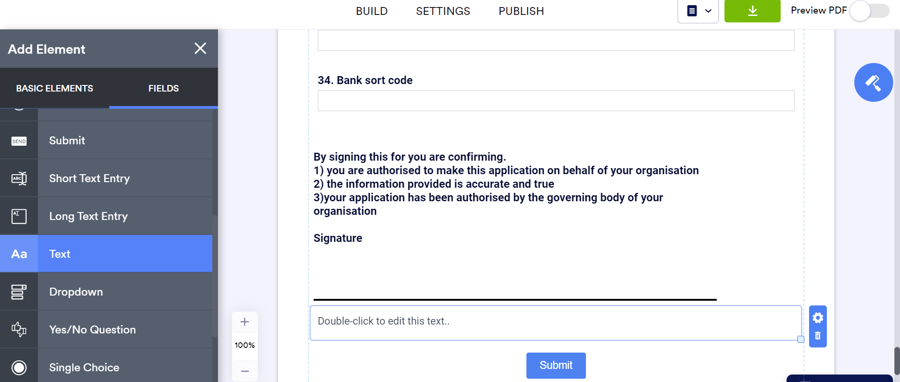

Scroll to the bottom below the signature section you will notice the document upload section is missing. From the left-hand menu select text and drag it in to position above submit.

Then go in to the second Jotform window you opened at the start, not the one you are working in.

Select edit form. Scroll to the bottom of the form and copy the text from the documents upload section using CTRL + C.

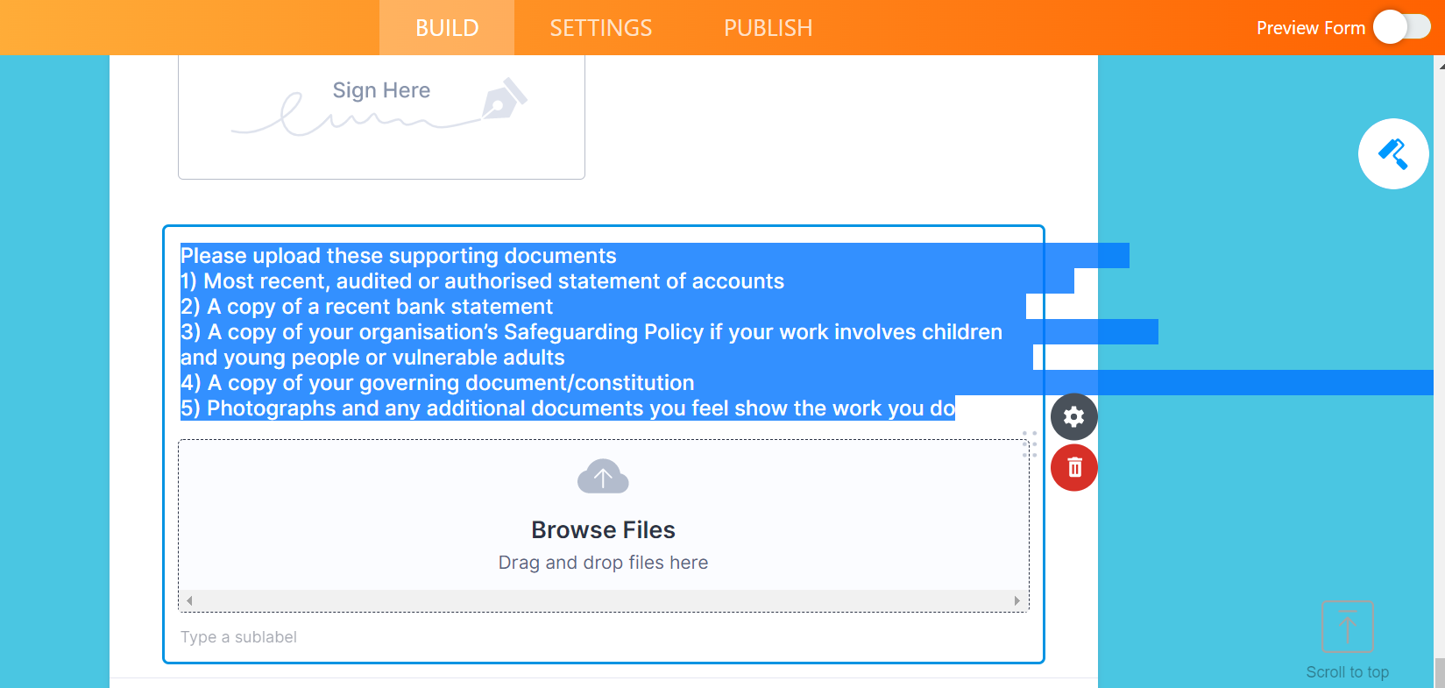

Go back to the first window you have been working in, where your form is in PDF editor double click in the text box you inserted above the submit button and paste the text you have just copied using CTRL +V.

Space out the questions as you would like them to appear in your PDF and press save.

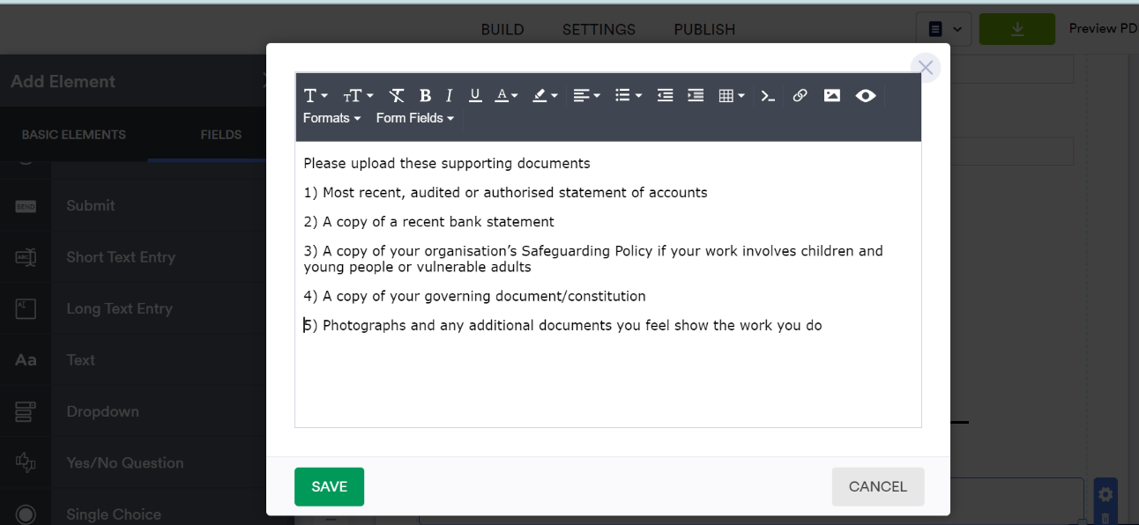

Now scroll down to the Submit button, left click on it and an icon of a bin will appear on the right-hand side, click that to delete the Submit button as it does not work on the PDF.

Your PDF is now ready. Give it a read through to check it looks the same as the online version and everything is in the right order/the questions are in the right place and then scroll to the top and click the green download button.

Save your downloaded PDF to your device and you can share this document with others now.

IMPORTANT FINAL STEP

*** As the PDF is taken from the web form your Submit button will also disappear from the web form. You will have to go back to your web form after you have downloaded your PDF and add the Submit button back to the web form. Go to Edit form, Build and Add Form Element which is in the top left-hand corner. Then select Submit from the left-hand menu and drag it to the bottom of the form so that the online form ends with the Submit button. ***

