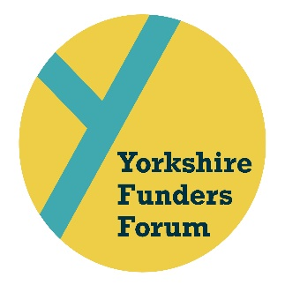
ROUNDTABLE SUMMARY
15 MAY 2019
GOODWIN DEVELOPMENT TRUST, HULL

Jan Garrill (Chair) Two Ridings Community Foundation
Carla Marshall (Co-ordinator) Sir George Martin Trust

- JG and CM welcomed all the new attendees to the Roundtable and explained the format and purpose of the group. The key difference between the former YGMFs (Yorkshire Grant Makers Forum) and the Roundtable meetings are that the focus is on learning from each other and working together to support the local third sector. The YGMFs, now called Yorkshire Funders Forum Autumn and Spring Conferences, continue to be predominantly focused on learning about the wider third sector and hearing from non-funder organisations, as well as funders from outside of Yorkshire. Networking and building relationships with other local funders is a key element of both the Roundtables and the Conferences. JG and CM made the group aware that a survey would go out asking all funders in Yorkshire their views on the integration of the two Forums as well as what information and services they would find most useful.

- The following funders shared details on their organisation, what and how they fund:
- Allen Lane Foundation, Charity Bank, Hesslewood Children’s Trust, Hillards Trust, Kirklees Council, Leeds Building Society Foundation, National Lottery Community Fund, Sir James Reckitt Charity and Two Ridings Community Foundation
The group were particularly interested in learning more about Charity Bank and social investment, as well Allen Lane Foundation’s transition from a paper to online application process. As a result, the Forum steering committee have ensured these two funders and the topics are a focus of the September Roundtable and November Conference.

- Karen Walke from South Yorkshire Funding Advice Bureau gave an update on the 9th October Focus on Funding event which will take place in Barnsley and is supported by a number of the Roundtable members. CM and KW explained the background to the event which was started in 2016 by the Forum in order to build relations between funding advisers and funders, and also support charitable groups via a funding fair.

- Pippa Robson (North Bank Forum) and Kaye Wilson (Voluntary Action Leeds) who are members of FAWN (Funding Advice Workers Network) gave an update. This is an important part of each Roundtable as FAWN meet quarterly and discuss issues they are seeing with local groups and it’s important they can share this information and ask funders questions in person. There were no burning issues to share at this Roundtable.

- CM told the group about the Forum’s SLACK portal and how news and information can be posted on here for funders and funding advisors to read. CM to share SLACK link so new people can join.

The next Roundtables will take place on:
- 18th September, 10.00am – 12.30pm at Wakefield Town Hall
- 14th November as part of the Autumn Conference, 9.30 – 10.45am at Thackray Medical Museum
- 5th February, 10.00am – 12.30pm at Leeds Civic Hall with ACF’s Stronger Foundation’s session 1.00 – 4.00pm

