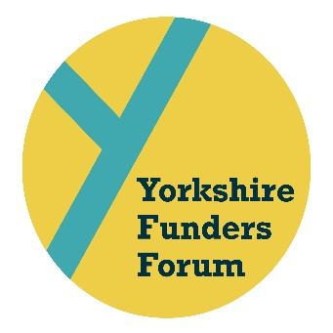

BOOKING & PAYMENT FORM

Please RSVP and make the £30.00 per person payment by Friday 1st November to:

Carla Marshall info@sirgeorgemartintrust.org.uk
or
6 Firs Avenue, Harrogate, HG2 9HA

Cheques should be made payable to Sir George Martin Trust.

Bank transfers can be made to:
HSBC Sir George Martin Trust
Sort code 40-13-15
Acc. no. 54300157
Organisation/delegate name as reference

NAME OF ORGANISATION

WHAT PARTS OF THE DAY WILL YOU ATTEND?

FULL DAY INCLUDING ROUNDTABLE & MAGGIE’S TOUR _______

FROM 10.45AM & MAGGIE’S TOUR _______

FROM 9.15AM, BUT NOT THE MAGGIE’S TOUR _______

FROM 10.45AM, BUT NOT THE MAGGIE’S TOUR _______
EMAIL ADDRESS & TELEPHONE NUMBER

NAME OF DELEGATE/S

