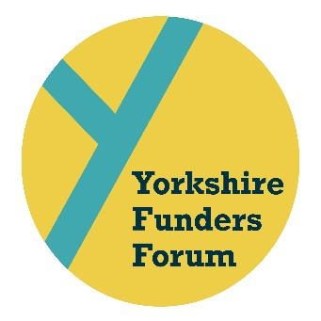

BOOKING & PAYMENT FORM

Please RSVP and make the £30.00 per person payment by Friday 8th May to:

Carla Marshall info@sirgeorgemartintrust.org.uk
or
6 Firs Avenue, Harrogate, HG2 9HA

Cheques should be made payable to Sir George Martin Trust.

Bank transfers can be made to:
HSBC Sir George Martin Trust
Sort code 40-13-15
Acc. no. 54300157
Organisation/delegate name as reference

NAME OF ORGANISATION

NAME OF DELEGATE/S

EMAIL ADDRESS & TELEPHONE NUMBER

CONSENT FOR YOUR ORGANISATION’S NAME TO FEATURE ON WWW.YORKSHIREFUNDERS.ORG.UK

A number of funders and front-line charitable organisations have said how useful it would be to have access to an online list of the grant makers which attend the YFF events. Following the 20th May Conference & Roundtable, we will be adding a list of the organisations which attended to the Resources page of the website. Only the organisation name will be featured.

If you are happy for your organisation’s name to appear on

www.yorkshirefunders.org.uk please tick/cross the box.

